《程序设计基础》

第三章作业

姓名：朱铭宇

学号：2020210574

班级：信息安全01班

学院：计算机与信息学院

3-9

#include<iostream>

using namespace std;

int judge(int i);

int main (void)

{

int i;

cout<<"请输入一个数："<<endl;

cin>>i;

if(judge(i))

cout<<i<<"是质数"<<endl;

else

cout<<i<<"不是质数"<<endl;

return 0;

}

int judge(int i)

{

int y,flag;

if(i>=2)

{

for(y = 2; y < i;y++)

{

flag =1;

if(i % y == 0)

{

flag = 0;

break;

}

}

}

else

flag = 0;

return flag;

}

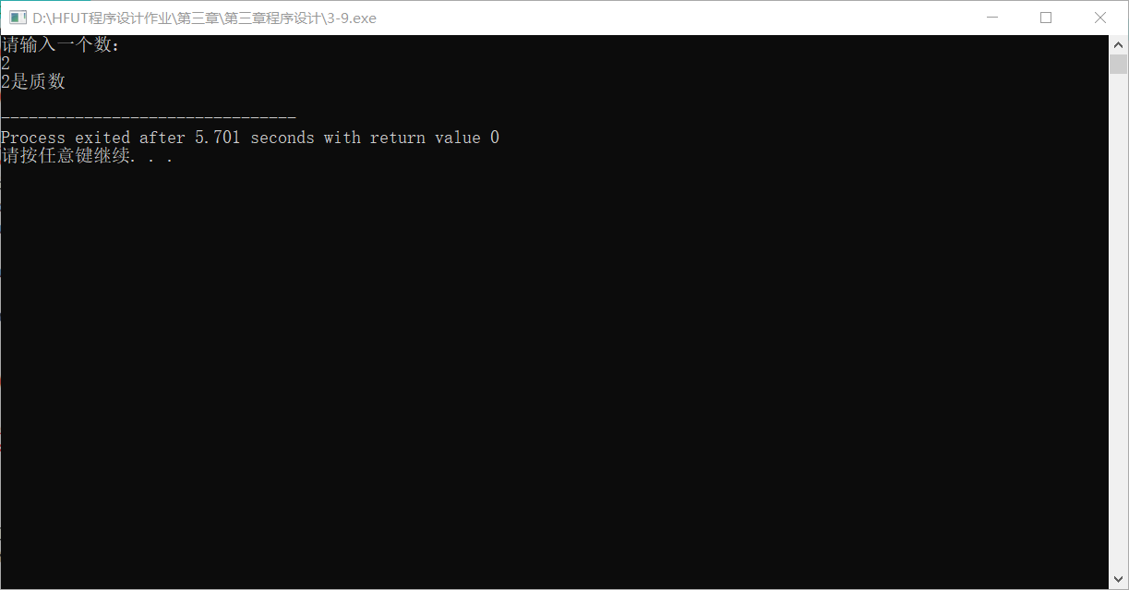

3-10

#include<iostream>

using namespace std;

void han(int x, int y);

void shu(int x, int y);

int main(void)

{

int x,y,t;

cout<<"请输入两个数"<<endl;

cin>>x>>y;

han(x,y);

shu(x,y);

return 0;

}

void han(int x, int y)

{

int m,n,p;

if(x>=y)

m = x;

else

m = y;

for(n=m;n>=1;n--)

if(x%n==0 && y%n==0)

{

p=n;

break;

}

cout<<x<<","<<y<<"的最大公约数为"<<p<<endl;

}

void shu(int x, int y)

{

int m,n,p,k;

if(x>=y)

m = x, k = y;

else

m = y, k = x;

for(n=m;n>=1;n--)

if(x%n==0 && y%n==0)

{

p=n;

break;

}

cout<<x<<","<<y<<"的最小公倍数为"<<p\*k<<endl;

}

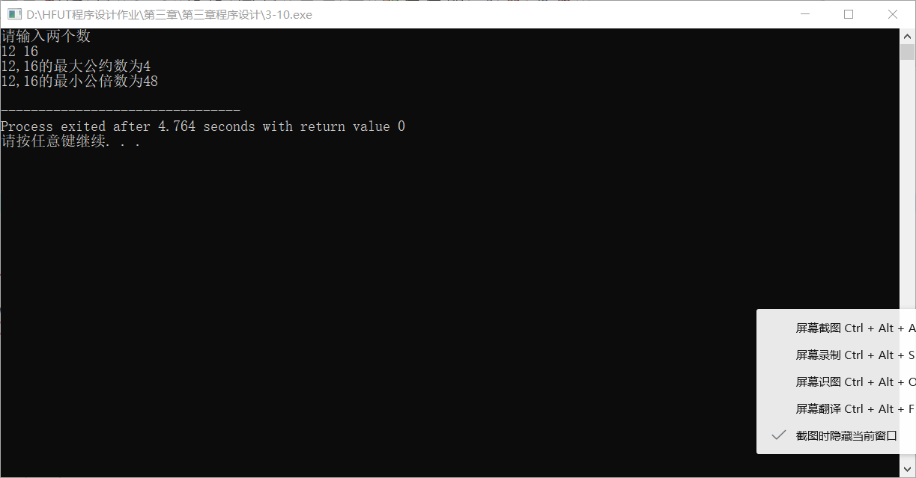

3-12

#include<iostream>

using namespace std;

int sum(unsigned n);

int main(void)

{

int n,k;

cout<<"请输入整数n："<<endl;

cin>>n;

k=sum(n);

cout<<k<<endl;

return 0;

}

int sum(unsigned n)

{

int f;

if(n==1)

f = 1;

else

f = sum(n-1)+n;

return f;

}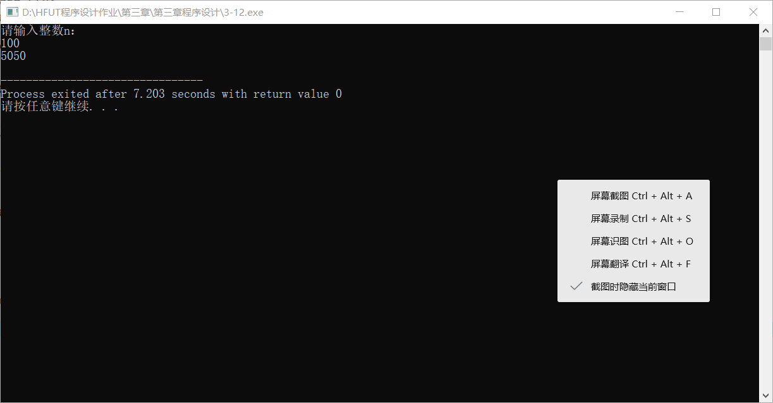

3-13

#include<iostream>

using namespace std;

int Fib(int n)

{

if(n == 0)

return 0;

else if(n == 1)

return 1;

else

return Fib(n-1) + Fib(n-2);

}

int main(void)

{

int n;

cout<<"请输入一个整数"<<endl;

cin>>n;

cout<<"Fib("<<n<<")="<<Fib(n)<<endl;

return 0;

}